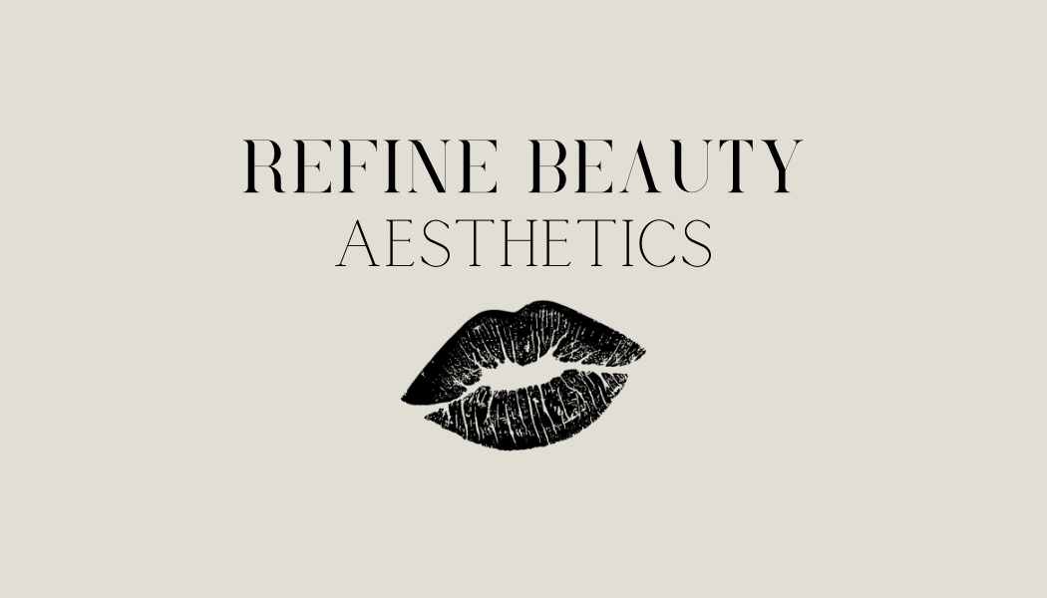

Information Management Policy:

Date effective: 02/02/24
Date review: 02/02/25
Version no: 1
Policy owner/author: Robyn Duffy

As part of Scottish Government guidelines Refine Beauty Aesthetics will protect patient confidentiality, information, and medical records. To reduce paper wastage and protect GDPR, the online app Fresha will be used for all consent forms, medical history forms, patient details and booking appointments. This is password protected and only accessible by Robyn. Robyn also follows the Caldicott principles to maintain patient safety.

Refine Beauty Aesthetics takes accountability for the safety and protection of our client’s information and uses this information only for the sole purpose of safe, effective treatment. The prospective client must complete the forms online themselves, or if unable to, give consent for the person completing it to do so (record of this will be required as well).

This is to demonstrate their consent to input their own information, but consent can be revoked as well by contacting Robyn directly. However, if the patient has had treatment, then revoked consent, a different process will be used. This is because if there is any medical concerns, complications or issues in the future, information will be required to assist the client. The minimum requirement of storing patient information/records for Scotland is 6 years from the last data entry until which the information can be removed or destroyed.

Robyn has also completed the modules information governance and safe information handling as part of her NHS post online.

The Data Protection Act 2018 includes 7 principles of data protection. These principles are designed to protect and ensure the law is followed. The following points explain why this is relevant to Refine Beauty Aesthetics:

- Lawfulness, fairness, and transparency – to ensure information is stored in a lawful way, consent must be obtained. This also includes the consent to share information with others should that be required. In Refine Beauty Aesthetics, this would only be relevant if further treatment was required elsewhere (like at a GP practice or hospital) or police presence was required. Information would only be shared with other healthcare professionals relevant to the treatment required and only the police if de-esclation attempts or risk of harm to Robyn was present. Every client consent form has a section which documents why Refine Beauty may need to share their personal information and if they consented to this.
- Purpose limitation – only relevant information will be obtained by Refine Beauty Aesthetics and stored on the Fresha App which is only accessible by Robyn. All forms sent to each client are written by Robyn and as such do not include questions that are irrelevant to the treatments provided.
- Data minimisation – no irrelevant information will be obtained and stored by Refine Beauty Aesthetics. Excessive information is not required, only the relevant information to safely continue with the treatment desired.
- Accuracy – all information must be relevant to the treatment. Therefore, Robyn has designed the required forms to provide the necessary questions to safely proceed. Should any information be provided that is inaccurate by the client, it shall be erased or rectified without delay. Each form has a section that has to be electronically signed by the client to confirm that the information given is correct. Robyn will check this information and verbally confirm with each client that they have given the correct detail.
- Storage limitation – information will be stored no longer than necessary. Retention periods are variable dependent for each record type in the NHS. Considering this and Scottish Law, Refine Beauty Aesthetics will retain client information for a period of 6 years from the date of the last entry. After the 6 years, the information will be erased permanently.
- Integrity and confidentiality – To prevent paper wastage and security risks, Refine Beauty Aesthetics will use the Fresha App to store all client data. This is password protected and only accessible by Robyn. This prevents the risk of unauthorised access and accidental loss, damage or destruction to the information.
- Accountability – Robyn takes fully accountability for the information provided by the client, from accessibility, storage and it’s uses. Robyn is the sole user of Refine Beauty Aesthetics on Fresha and does not provide any other person(s) access. Should a client wish to view the information stored on their own client profile, a formal email or letter should be sent to Refine Beauty Aesthetics to request this. All requests will be responded to within 1 month. Robyn can be contacted at refinebeautyaesthetics@hotmail.com or by writing to: Refine Beauty Aesthetics, 33 Castlebank Gardens, Cupar, KY15 4DA.

Following the Caldicott Principles, Refine Beauty Aesthetics has provided 8 points to explain why information is held.

- All information required by Refine Beauty Aesthetics is to maintain the safety of client. Patient details, consent forms and a medical history form are required so the practitioner can assess the patient’s suitability for treatment, act if any complications arise, or provide information to other medical practitioners should they require further intervention from a hospital or GP. It also allows the practitioner to contact any next of kin and/or contact the patient out with appointment time.
- Due to the nature of treatments, confidential information is required to maintain safety. However, this information will only be accessed when necessary and should the client not seek further treatment, will be removed/destroyed six years after the last data entry as per Scottish GDPR rules.
- The minimum amount of confidential information has been requested suited to the requirements for legal purposes and safety of the treatments.
- Client information will be only accessed by Robyn unless there is a medical emergency and further intervention is required. In this instance, client information will be given to medical professionals (eg. GP or Hospital) to assist with treatment required.
- As medical practitioners, we are regulated by professional bodies like the Nursing and Midwifery Council (NMC) or General Medical Council (GMC) and therefore have a duty to protect patient confidentiality and information. If there was a medical emergency during treatment at the clinic, Robyn will communicate with the necessary professionals and highlight patient confidentiality and information protection.
- Robyn will maintain lawful practice and store information correctly. To reduce paper wastage and reduce security concerns, the online app Fresha will be used for client information. This is password protected and only accessible by Robyn.
- As part of patient protection, healthcare professionals need to have confidence information will be shared to maintain client safety. As a healthcare practitioner working in the NHS, Robyn has an excellent understanding of this and how to communicate with other medical professionals if required.
- All patients will be made aware at their face-to-face consultation and online via the Fresha app of how their information will be stored and used. This is to give the patient the choice of whether to seek treatment or not, and how their information may potentially be used in the future should further intervention be required. Should patients wish to seek access to their own records, a written request to Refine Beauty Aesthetics should be submitted detailing their request.

